Overy Staithe Sailing Club Sharpie Open meeting
Saturday 19th May and Sunday 20th May
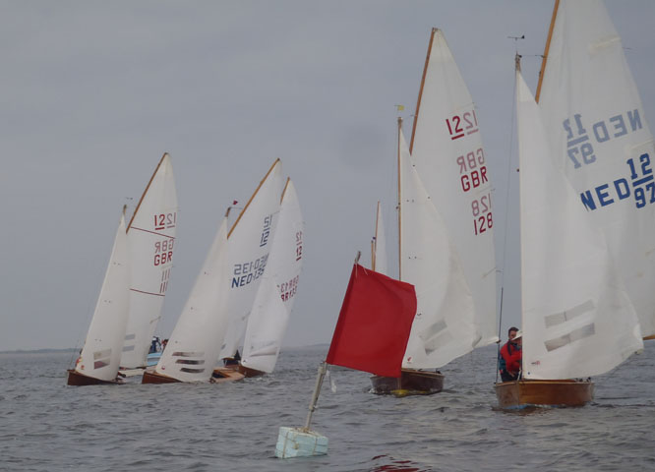
An opportunity to fine tune your sailing skills prior to the Nationals
Four races - two on Saturday and two on Sunday
Racing will be at sea if possible
Tea/coffee available after the racing

Saturday racing Sunday racing
Briefing on the quay at 8:00 First race 9:45
First Race 9:00 Prize-giving afterwards in the Boathouse

Entry Fee : £10
For further details contact Andy Turner 01328 730 905 (andyturner2123@gmail.com)

